**3.20 Meeting**

Data: MIMIC-IV v3.1, MIMIC-IV-Note v2.2

Downloaded to local computer. (BigQuery for google cloud.)

MIMIC IV: *hosp, (icu)*

hospitalization & emergency

Time range: 2008 - 2022 (anchor_year_group: “2020-2022” vs others)

Count of patients with related primary diagnosis:

Group patients by admitted year group:

MIMIC-IV-Note: *discharge*, *discharge_detail,* (*radiology*, and *radiology_detail)*

Only notes occurring within one year of a patient encounter are included in the database, where an encounter is defined as an emergency department or hospital stay

*v2.2: doesn’t have the updated data from 2020 to 2022

Number clinical notes available:

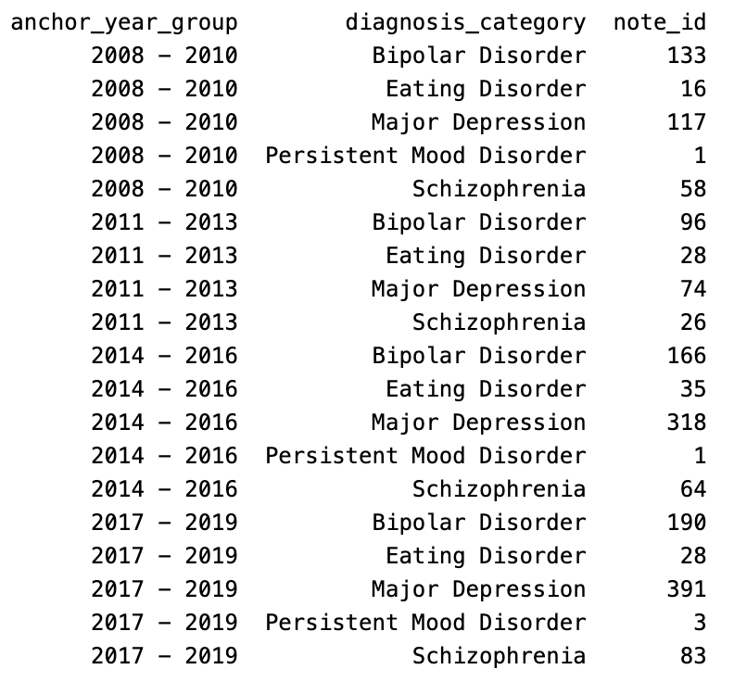

Average note length:

To Do:

1. Upload the data to HPC

docs: https://researchit.jhu.edu/research-hpc/

path: /projects/opennotes

create folder: data/fli49, clone the git repo here

1. Analyze the MIMIC IV data to get a more in depth time trend (can’t get actual time)

Two approaches: (1) aggregate on patients, see the overall trend; (2) focus on some patients with multiple clinical notes, track the difference in notes at different time periods (relative time for each patient is accurate)

1. Send email to MIMIC authors. (1) ask the authors if they have the clinical notes after 2020; (2) ask Beth Isareal when they adopted open notes